SIMATS ENGINEERING
ASSESSMENT TOOL 2
COURSE NAME: CSA07
COURSE CODE: Computer Networks

COURSE OUTCOME COVERED
CO1: Apply the functions of OSI layer in enabling reliable data transmission across networks. (BL2, BL3)
Assessment Tool Weightage: 30%

Annexure A
CONCEPT MAPPING
Dr. V. PARTHIPAN

Code of Conduct:
I am ( velarasan S / 192571087) certify that this submission is my original work and that I have adhered to the guidelines specified for this assessment. I understand that any violation of academic integrity rules will result in disciplinary action. Signature of the student:
CSA0706 COMPUTER NETWORKS SLOT C

Annexure A – Concept Mapping (With Questions )

1. A partially completed concept map is given below:
Question:
Application → Presentation → ______ → Transport → Network → ______ → Physical
Analyse the missing layers and explain how their functions are essential for reliable communication.
Answer:
Completed Concept Map:
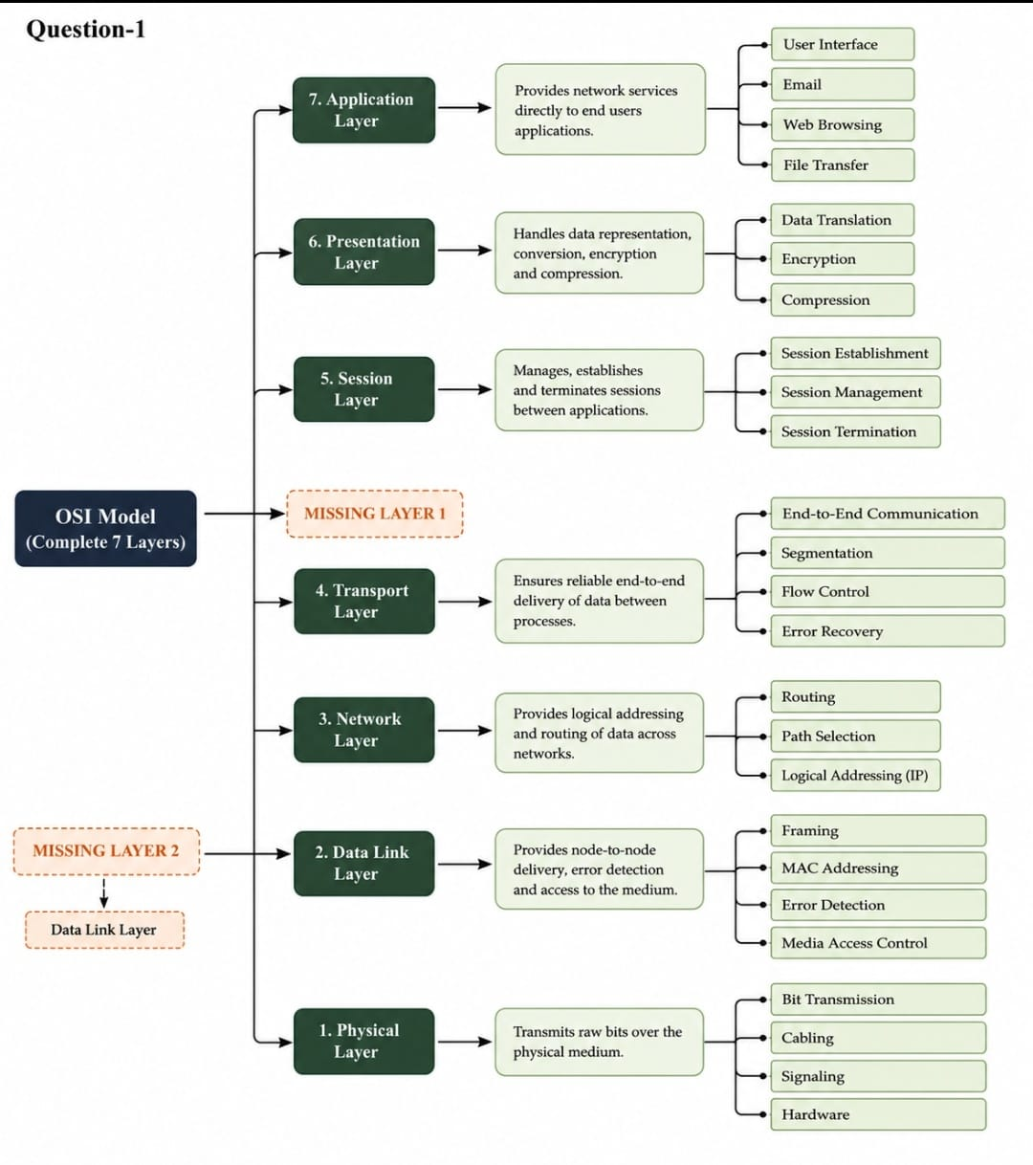
Missing Layers:
- Session Layer
- Data Link Layer
Explanation:
- Session Layer: Establishes, manages, and terminates communication sessions between devices.
- Data Link Layer: Provides framing, error detection, and reliable transmission over the physical medium.
These layers ensure organized, synchronized, and reliable communication.

2. Construct a concept map linking data units (Segment, Packet, Frame, Bits) with their respective OSI layers and analyse how transformation of data units supports transmission.
Answer:
Concept Map:
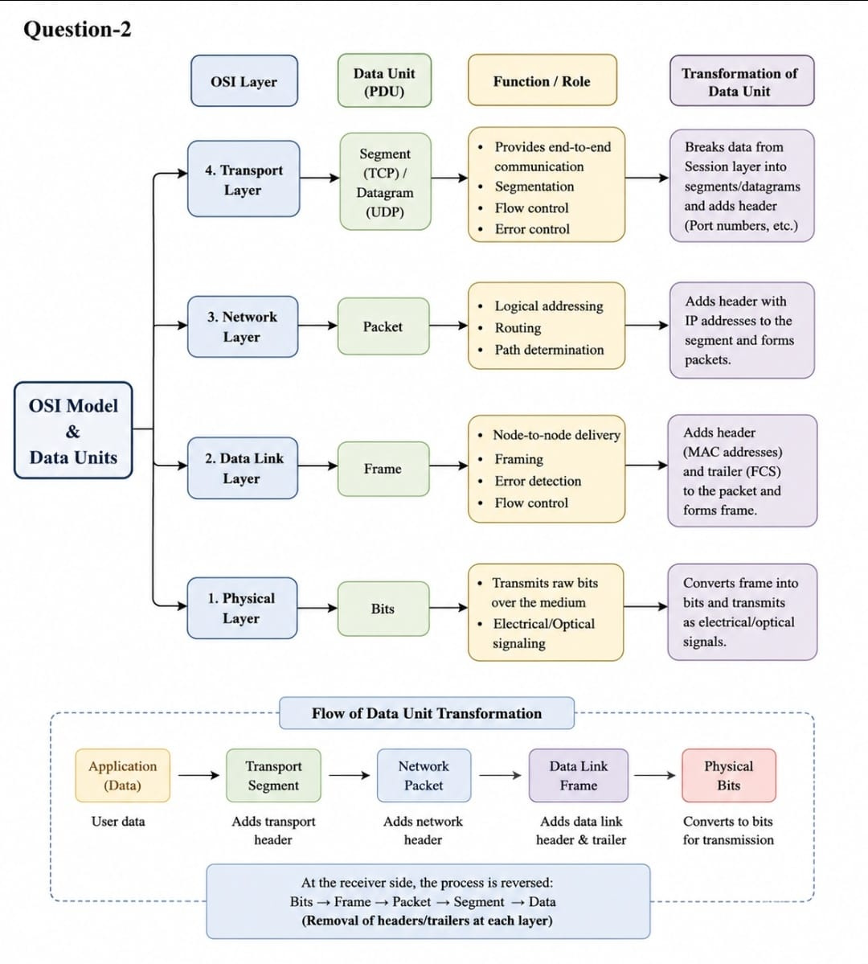
Explanation:
OSI Layer | Data Unit
Transport | Segment
Network | Packet
Data Link | Frame
Physical | Bits
Analysis:
As data travels through the OSI layers, it is converted from Segments → Packets → Frames → Bits. This process is called Encapsulation, which ensures efficient and reliable transmission across networks.

3. Given the concept map:
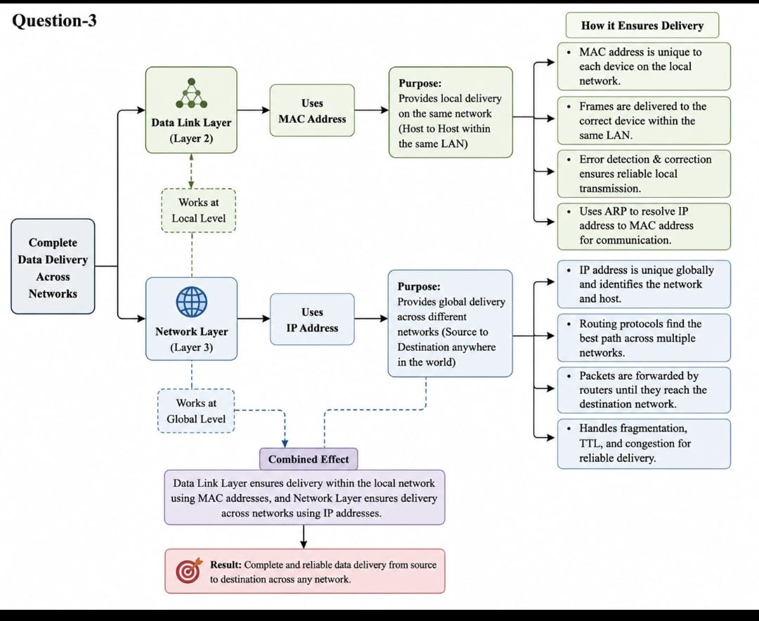
Answer:
Explanation:
- MAC Address is used by the Data Link Layer for communication within the same local network.
- IP Address is used by the Network Layer to route data across different networks.
Analysis:
The IP address identifies the destination network, while the MAC address identifies the destination device within that network. Together, they ensure accurate end-to-end data delivery.

4. A concept map shows:
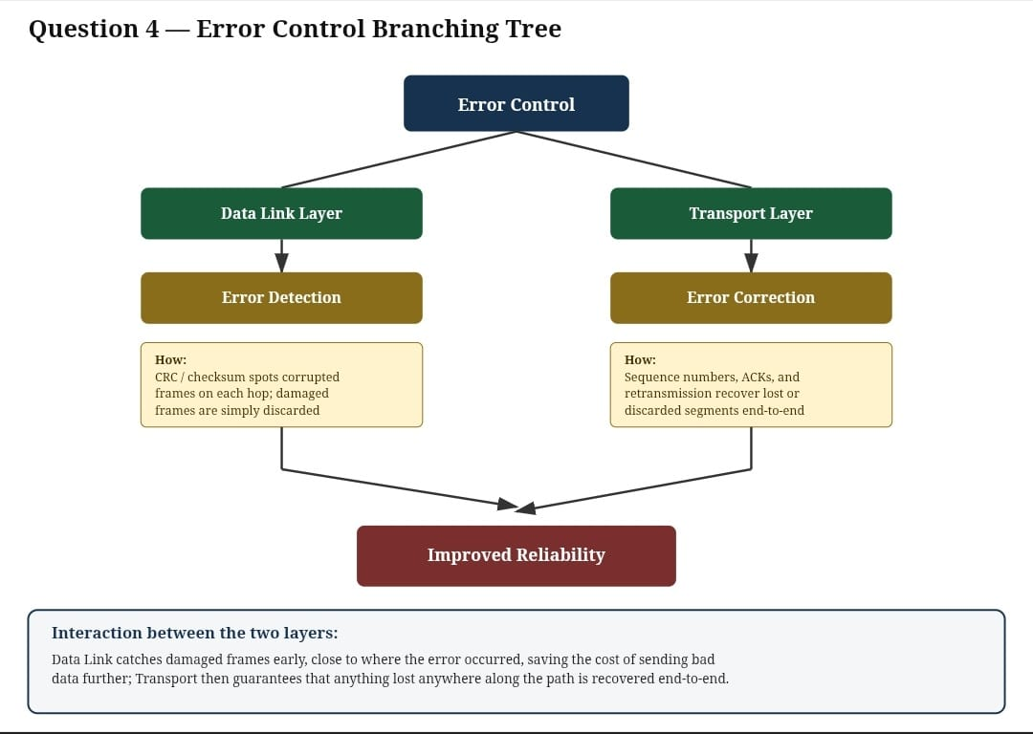
Answer:
Explanation:
- Data Link Layer: Detects errors using techniques such as CRC or checksum.
- Transport Layer: Ensures reliable delivery through acknowledgments, sequencing, and retransmission.
Analysis:
The Data Link Layer detects transmission errors, while the Transport Layer corrects communication errors by retransmitting lost or damaged data. Together they provide reliable communication.

5. Develop a concept map for web browsing using OSI layers and analyze how failure in one layer affects the entire communication process.
Answer:
Concept Map: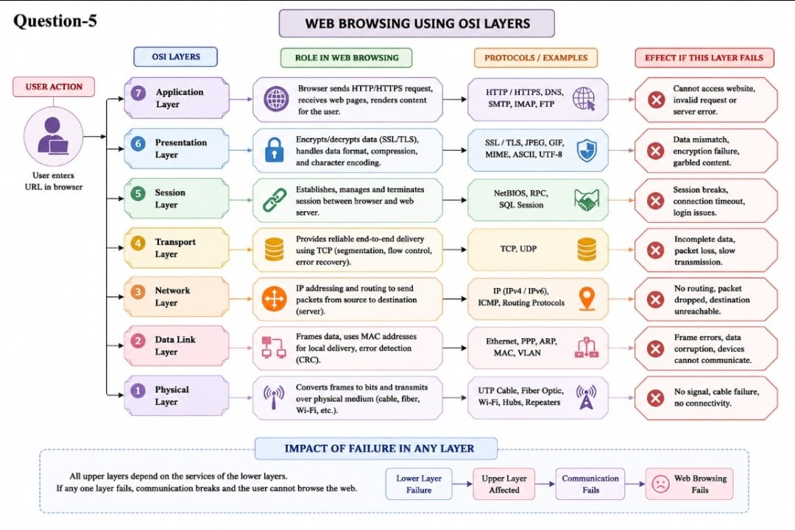
Analysis:
If any layer fails, communication is interrupted.
For example:
- Physical Layer failure → No network connection.
- Network Layer failure → Packets cannot reach the destination.
- Transport Layer failure → TCP connection cannot be established.
- Application Layer failure → Web pages cannot be accessed.
Each layer depends on the successful operation of the lower layers.

6. A network issue is represented in the concept map:
Physical ✔ → Data Link ✔ → Network ✖ → Transport ✖ → Application ✖
Analyse the problem and explain how the concept map helps in troubleshooting.
Answer:
Analysis:
- The Physical Layer and Data Link Layer are functioning correctly.
- The failure begins at the Network Layer, indicating issues such as:
  - Incorrect IP address
  - Router failure
  - Incorrect subnet mask
  - Routing problem
Because the Network Layer has failed:
- The Transport Layer cannot establish end-to-end communication.
- The Application Layer cannot access services such as web browsing, email, or file transfer.
Conclusion:
The concept map helps identify the exact layer where communication fails, making troubleshooting easier and faster.

